~~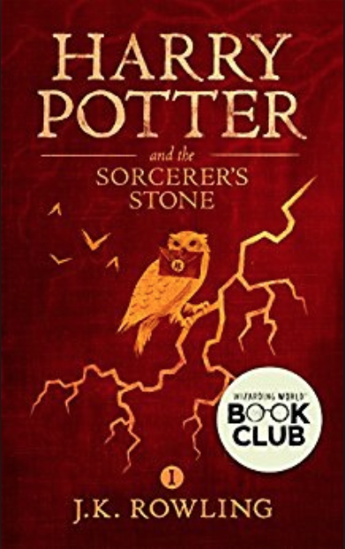~~

Name: **Harry Potter and the Sorcerer's Stone**

Author:  **J．K Rowling**

Abstract: *"Turning the envelope over, his hand trembling, Harry saw a purple wax seal bearing a coat of arms; a lion, an eagle, a badger and a snake surrounding a large letter 'H'."  
Harry Potter has never even heard of Hogwarts when the letters start dropping on the doormat at number four, Privet Drive. Addressed in green ink on yellowish parchment with a purple seal, they are swiftly confiscated by his grisly aunt and uncle. Then, on Harry's eleventh birthday, a great beetle-eyed giant of a man called Rubeus Hagrid bursts in with some astonishing news: Harry Potter is a wizard, and he has a place at Hogwarts School of Witchcraft and Wizardry. An incredible adventure is about to begin!*

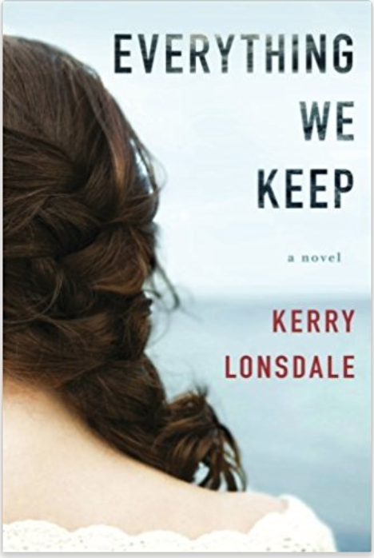

# Name: Everything We Keep: A Novel (The Everything Series)

Author: **Kerry Lonsdale**

Abstract: *A luminous debut with unexpected twists, Everything We Keep explores the devastation of loss, the euphoria of finding love again, and the pulse-racing repercussions of discovering the truth about the ones we hold dear and the lengths they will go to protect us.*

*Sous chef Aimee Tierney has the perfect recipe for the perfect life: marry her childhood sweetheart, raise a family, and buy out her parents’ restaurant. But when her fiancé, James Donato, vanishes in a boating accident, her well-baked future is swept out to sea. Instead of walking down the aisle on their wedding day, Aimee is at James’s funeral—a funeral that leaves her more unsettled than at peace.*

*As Aimee struggles to reconstruct her life, she delves deeper into James’s disappearance. What she uncovers is an ocean of secrets that make her question everything about the life they built together. And just below the surface is a truth that may set Aimee free…or shatter her forever.*

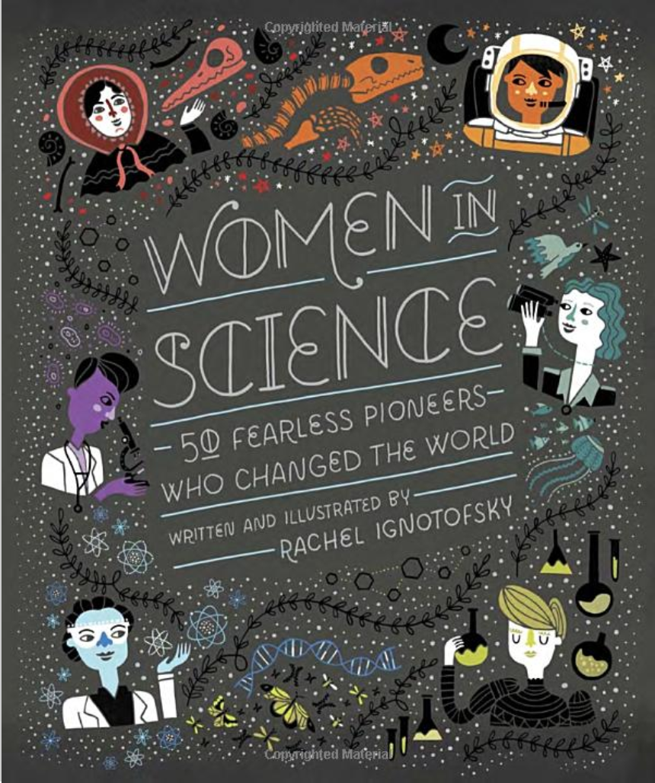

# Name: Women in Science: 50 Fearless Pioneers Who Changed the World

Author: **Rachel Ignotofsky**

Abstract: **It’s a scientific fact: Women rock!**  
   
*A charmingly illustrated and educational book, New York Times best seller Women in Science highlights the contributions of fifty notable women to the fields of science, technology, engineering, and mathematics (STEM) from the ancient to the modern world. Full of striking, singular art, this fascinating collection also contains infographics about relevant topics such as lab equipment, rates of women currently working in STEM fields, and an illustrated scientific glossary. The trailblazing women profiled include well-known figures like primatologist Jane Goodall, as well as lesser-known pioneers such as Katherine Johnson, the African-American physicist and mathematician who calculated the trajectory of the 1969 Apollo 11 mission to the moon.   
   
Women in Science celebrates the achievements of the intrepid women who have paved the way for the next generation of female engineers, biologists, mathematicians, doctors, astronauts, physicists, and more!   
  
— BrainPickings - Best Science Books of the Year*

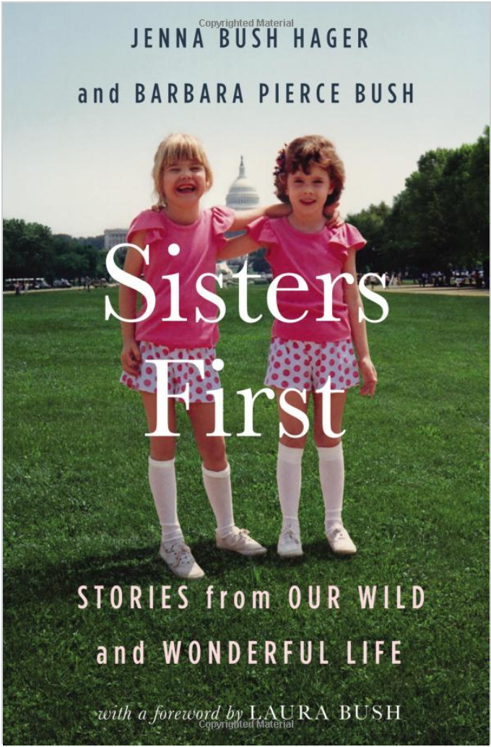

# Name: Sisters First: Stories from Our Wild and Wonderful Life

Author: Jenna Bush Hager

Abstract: ***#1 New York Times Bestseller  
  
Former first daughters and #1 bestselling authors Jenna Bush Hager and Barbara Pierce Bush share intimate stories and reflections from the Texas countryside to the storied halls of the White House and beyond.****Born into a political dynasty, Jenna and Barbara Bush grew up in the public eye. As small children, they watched their grandfather become president; just twelve years later they stood by their father's side when he took the same oath. They spent their college years watched over by Secret Service agents and became fodder for the tabloids, with teenage mistakes making national headlines.   
But the tabloids didn't tell the whole story. In SISTERS FIRST, Jenna and Barbara take readers on a revealing, thoughtful, and deeply personal tour behind the scenes of their lives, as they share stories about their family, their unexpected adventures, their loves and losses, and the sisterly bond that means everything to them.*

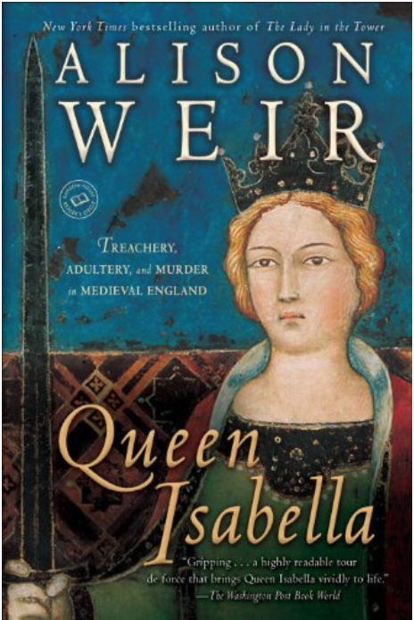

# Name: Queen Isabella: Treachery, Adultery, and Murder in Medieval England

Author: **Alison Weir**

Abstract:

*BONUS: This edition contains an excerpt from Alison Weir's Mary Boleyn.  
  
In this vibrant biography, acclaimed author Alison Weir reexamines the life of Isabella of England, one of history’s most notorious and charismatic queens. Isabella arrived in London in 1308, the spirited twelve-year-old daughter of King Philip IV of France. Her marriage to the heir to England’s throne was designed to heal old political wounds between the two countries, and in the years that followed she became an important figure, a determined and clever woman whose influence would come to last centuries. Many myths and legends have been woven around Isabella’s story, but in this first full biography in more than 150 years, Alison Weir gives a groundbreaking new perspective.*